ASSIGNMENT

Objective:

Design an application for student management system

Problem Statement:

A popular education society "EduExcellence" is setting up a new school in the city. They want a "School Management Software" that should match the high standards of the school that they aspire to build. They have hired you to provide them with the software that should enable them to manage all aspects of running a school successfully, but they would want the application to grow gradually with the growth of the new school.

Assignment:

1.Implement an OAuth2 server

2. OAuth2 server should issue JWT

3. Make API Gateway as Resource Server

4. Enable API Gateway to validate JWT

Use Spring Cloud oauth2(2.2.5.RELEASE) and Spring oAuth2 Resource Server.

SOLUTION:

* Eureka Server is used for service registry and service discovery.
* API Gateway is implemented to route the requests.
* OAuth server is used for client validation.
* OAuth server issues JWT after authentication and authorization
* API Gateway acts as resource server and route the requests to services and successful validation.

Eureka Server runs at port : 8761

API Gateway runs at port: 8989

Student Management Service runs at port: 8084

Fee Management Service runs at port: 8083

SCREENSHOTS:

1. All services registered with Eureka Server:

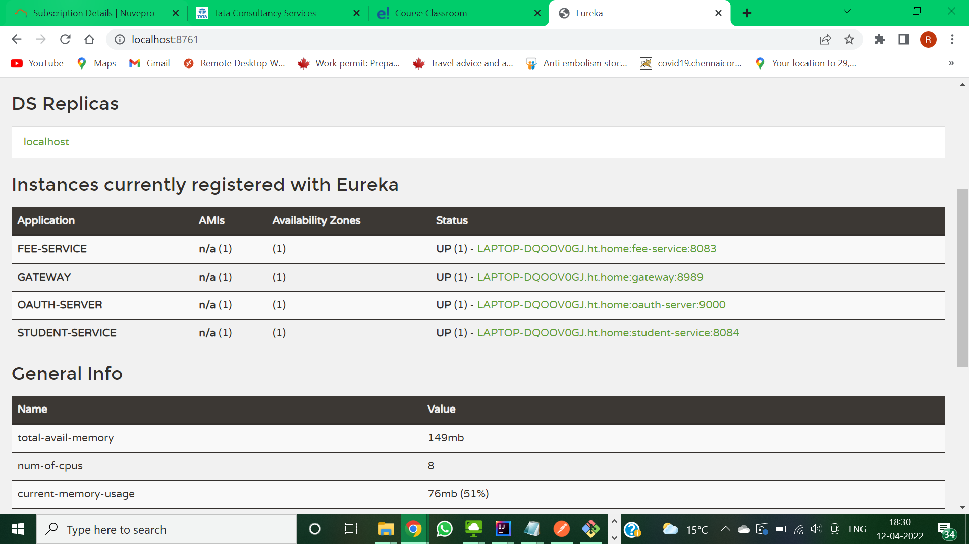

1. Accessing APIGateway to get Token from OAUTH server using POSTMAN.

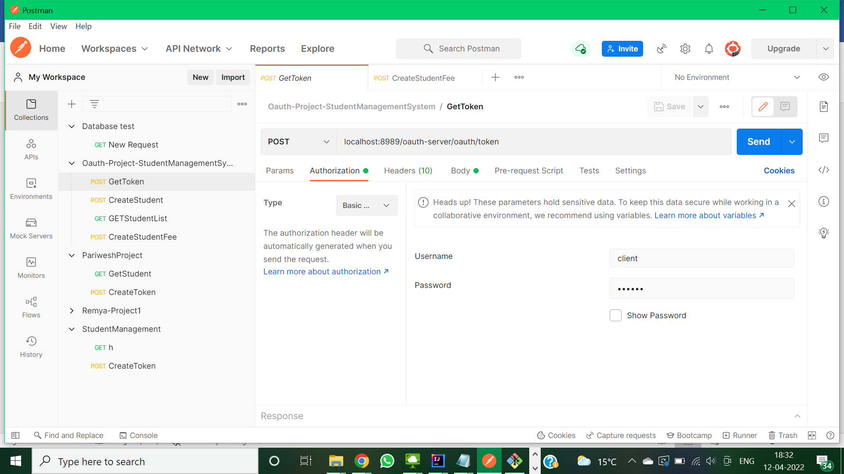

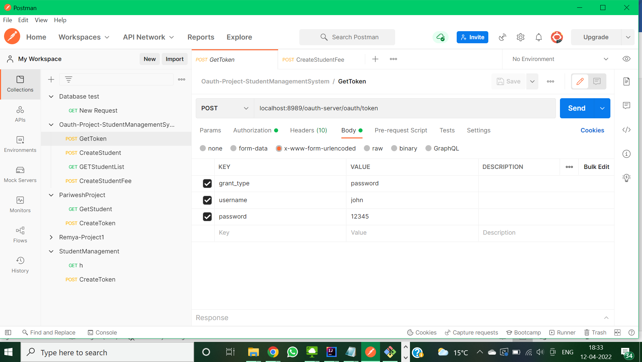

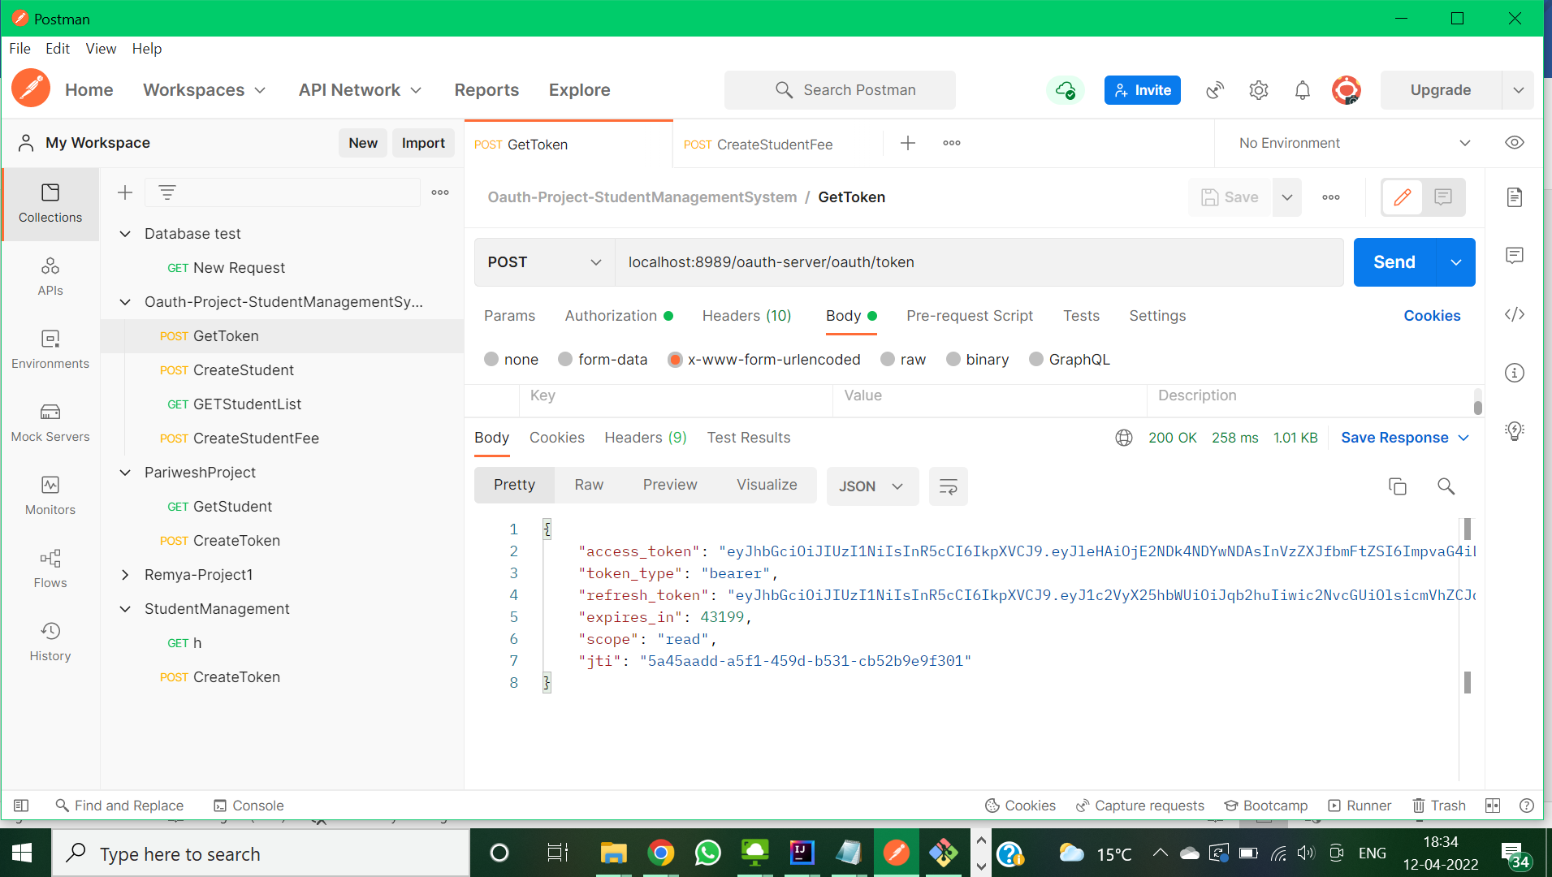

1. Accessing Student Management service without token resulting in unauthorized access via API Gateway:

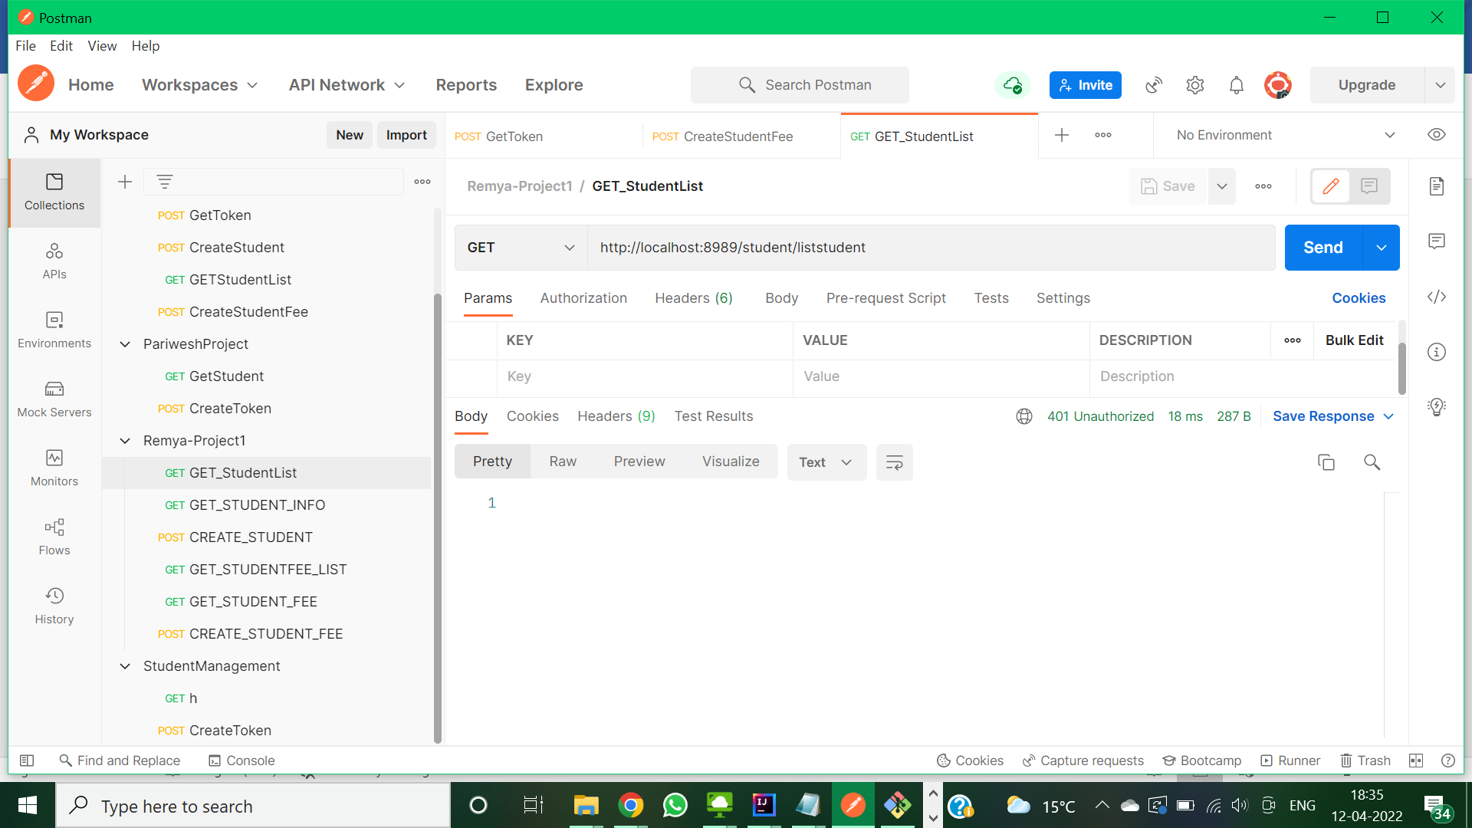

1. Accessing StudentManagement service via API Gateway with JWT Token :

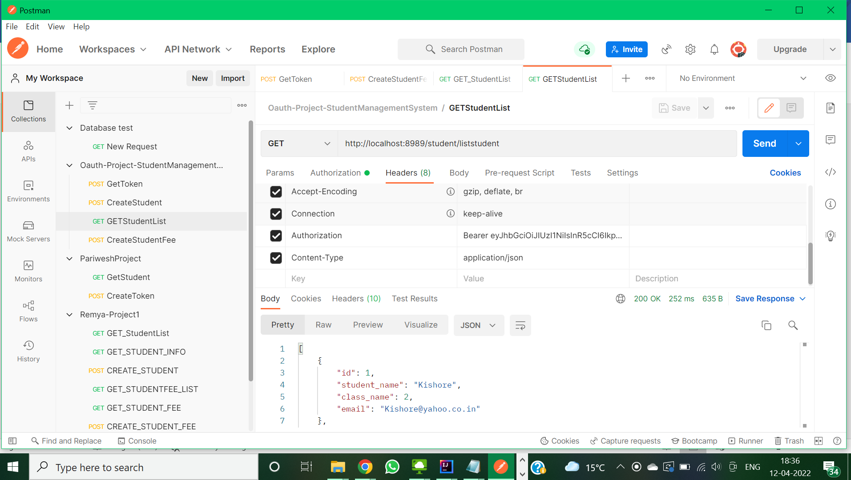

1. Accessing Fee Management Service via API Gateway without token:

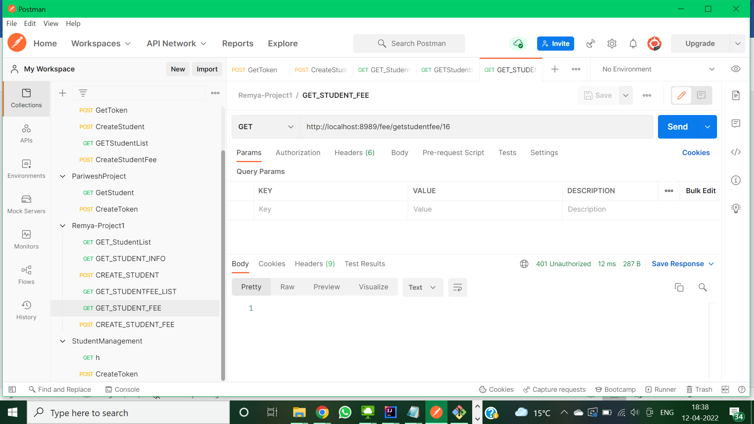

1. Accessing Fee Management Service via API Gateway with JWT token:

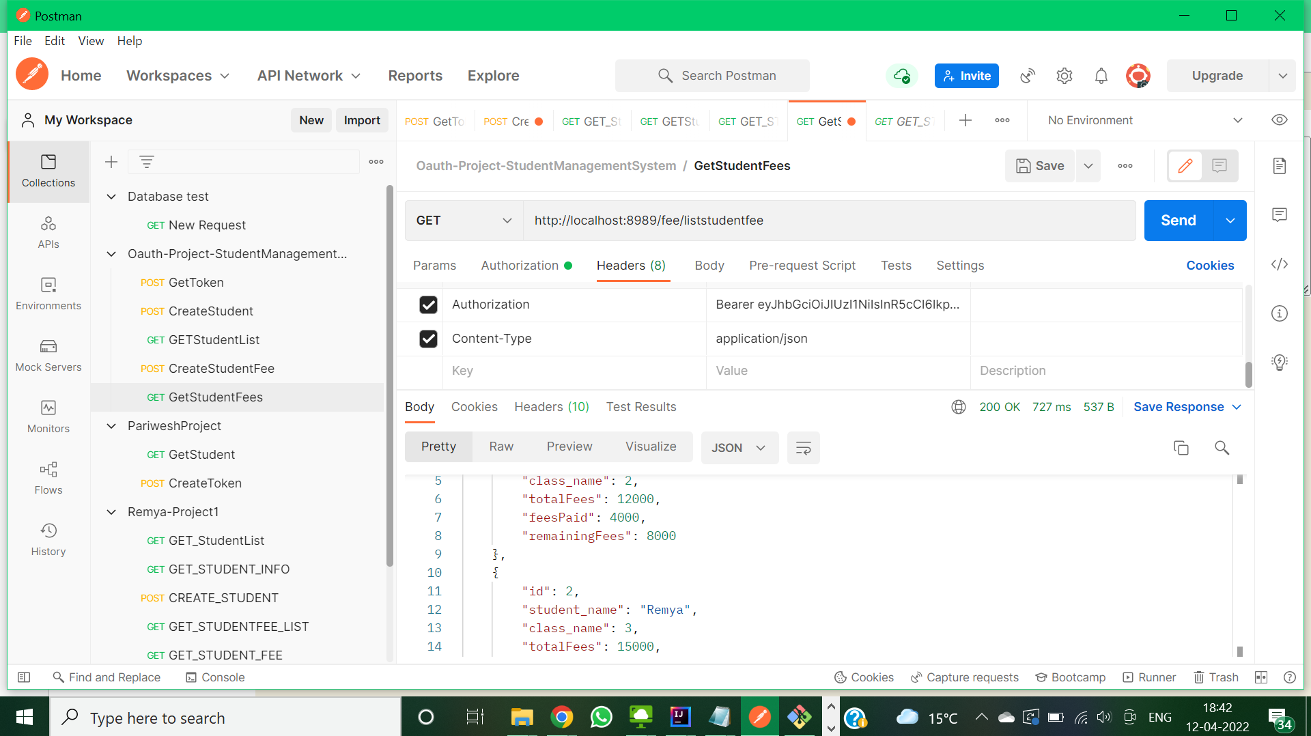

Source Code:

OAuth Server:

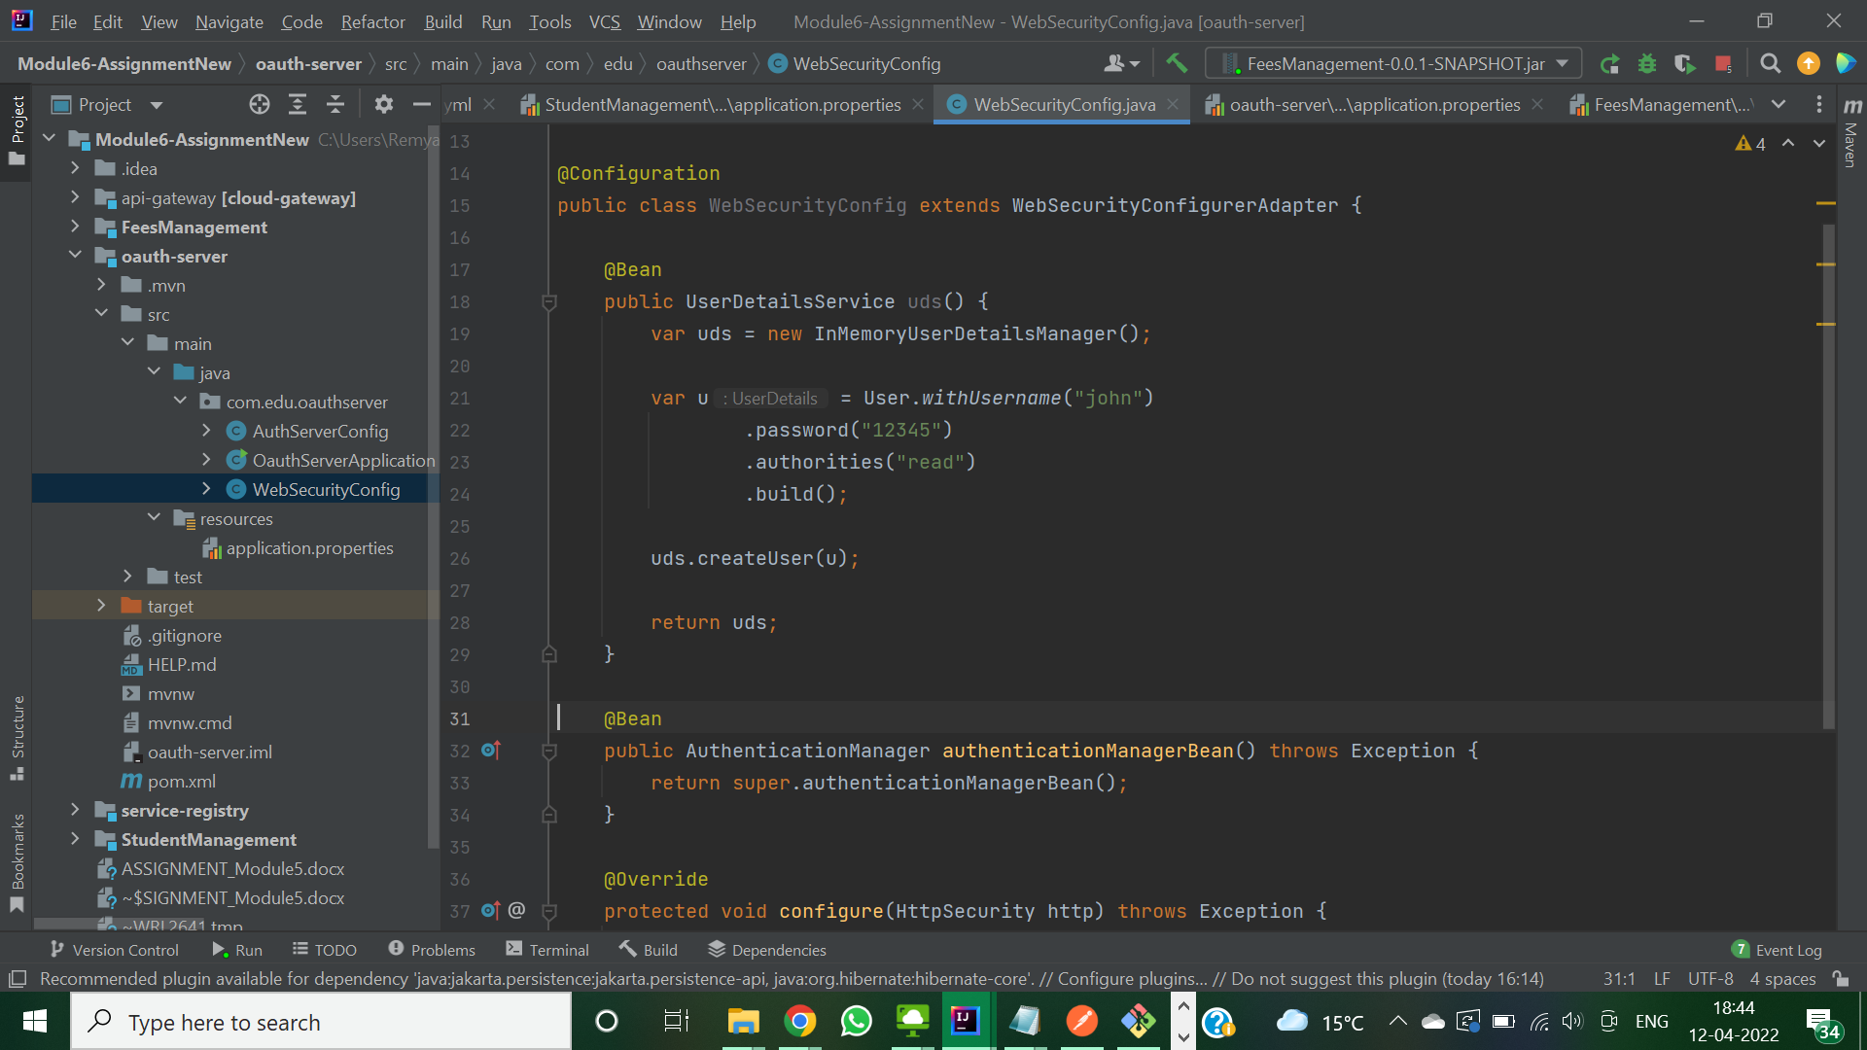

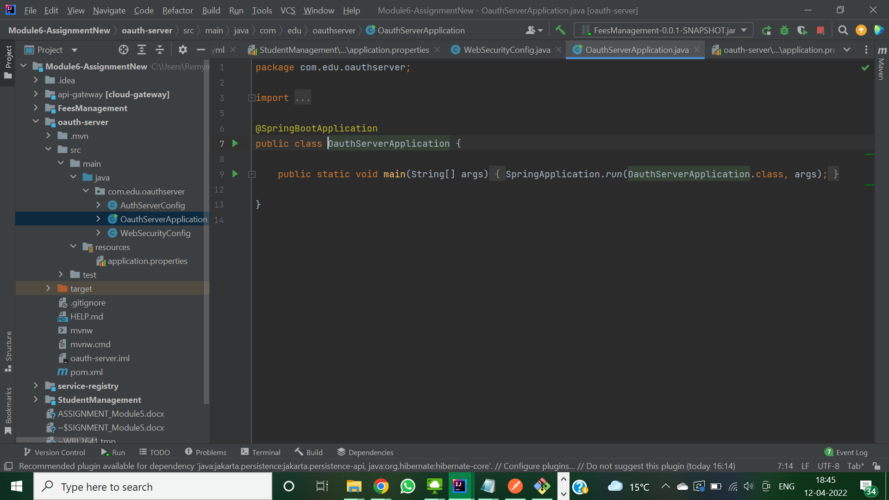

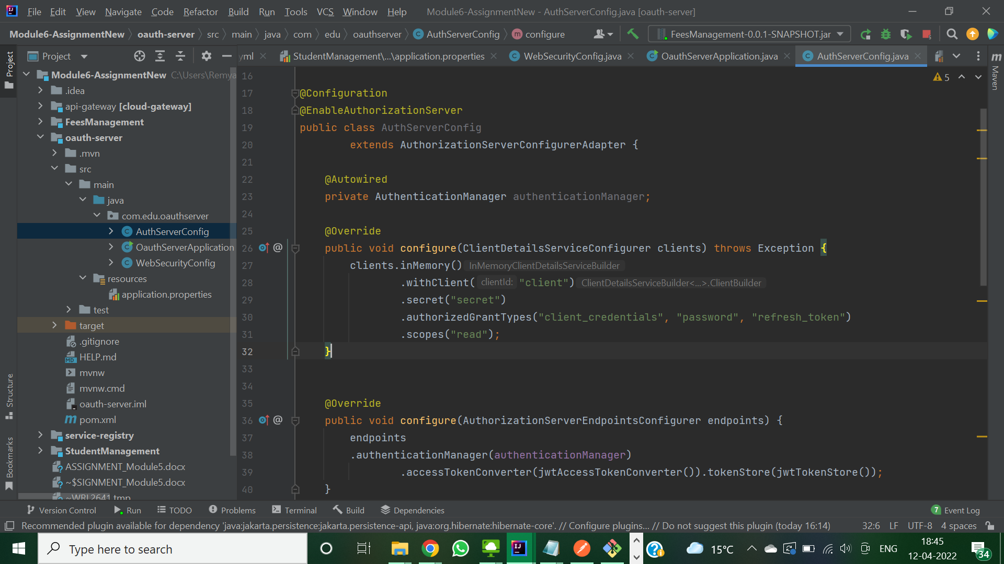

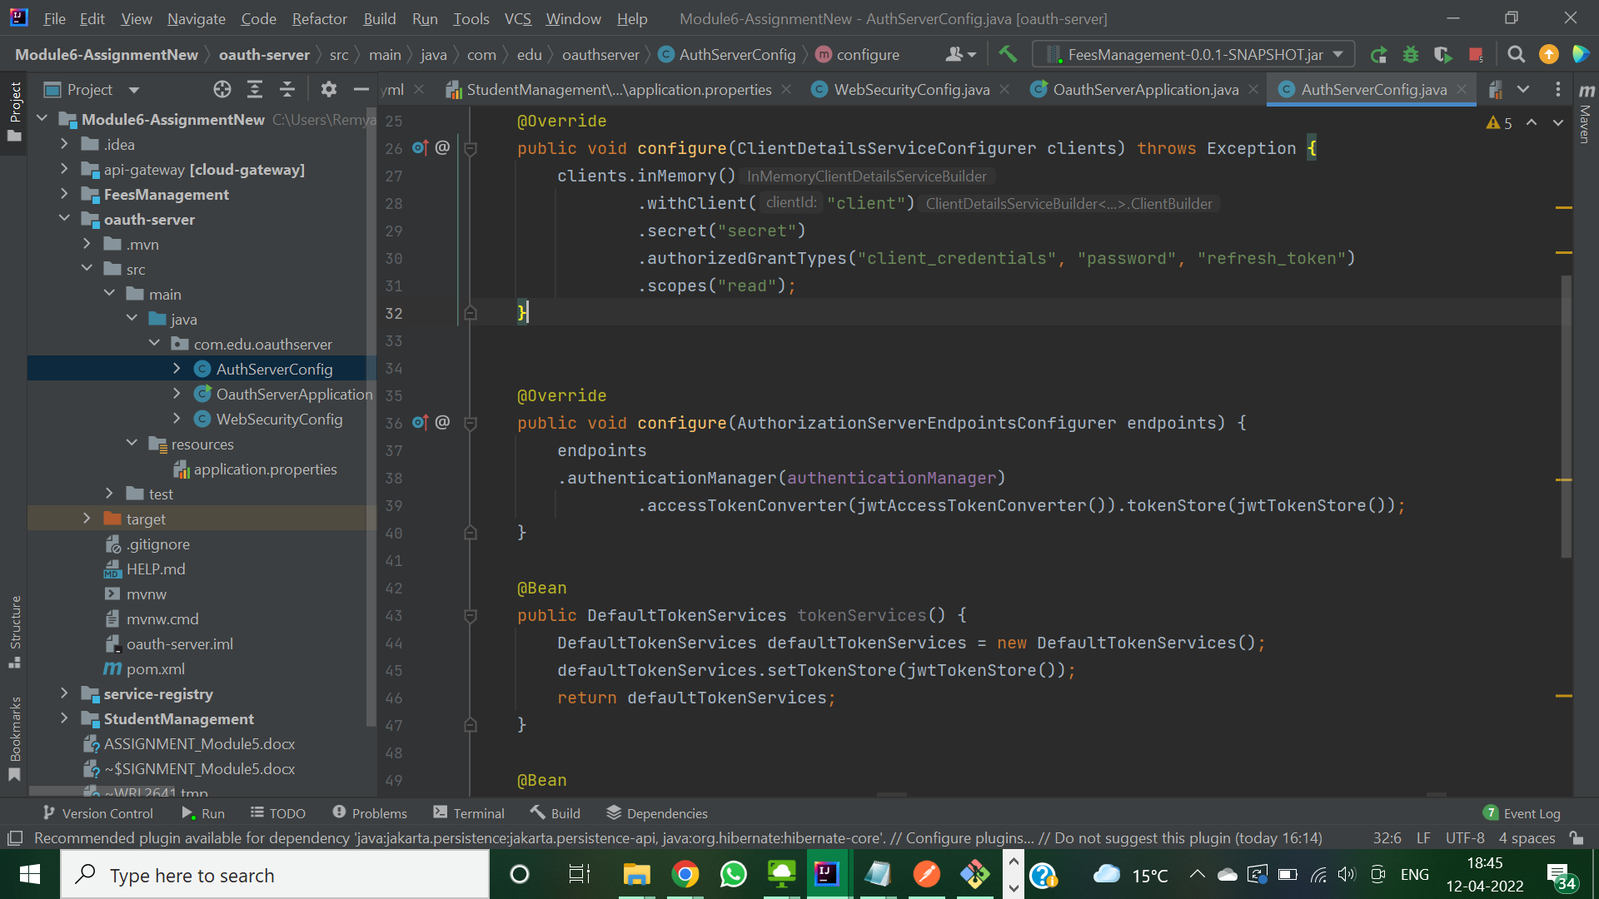

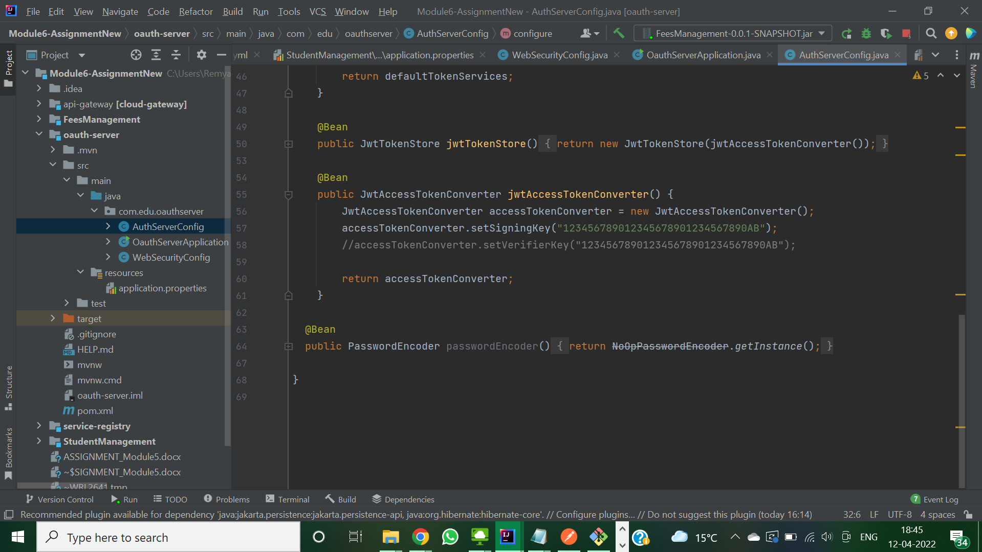

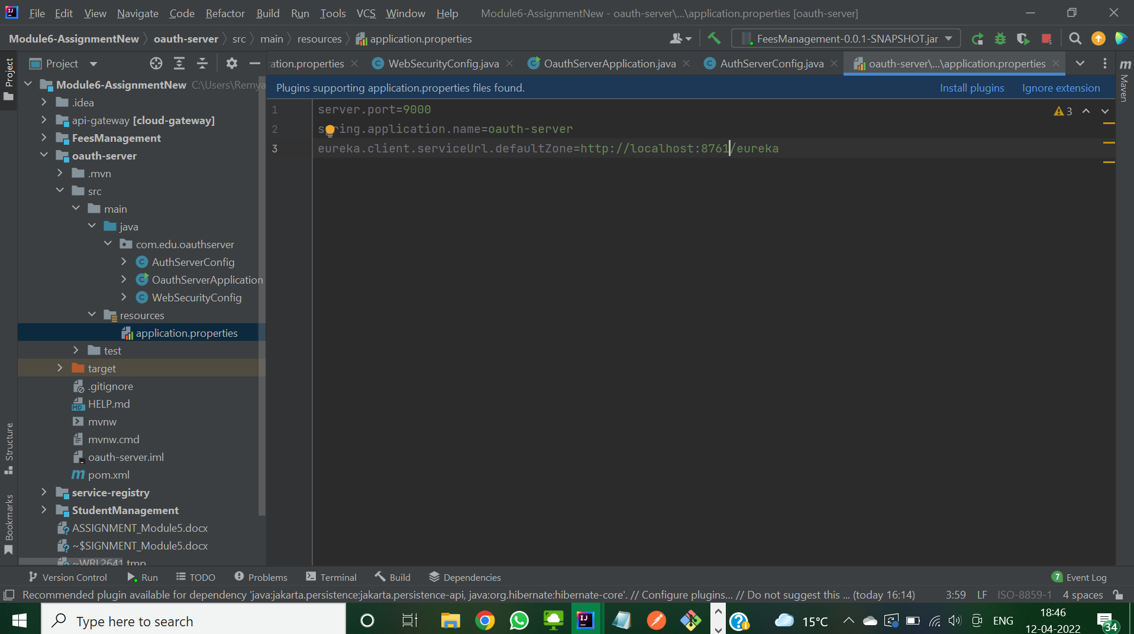

APIGATEWAY AS Resource Server:

